Presidential Proclamation Requires $100,000 Fee for New H-1B Workers

On September 19, 2025, the President issued a Proclamation that temporarily halts decisions on new H-1B petitions and bans entry of certain H-1B workers, unless a $100,000 fee is paid. The Proclamation took effect **September 21, 2025, at 12:01 a.m. EDT** for twelve months (with the possibility of an extension).

While the language of the Proclamation appeared to apply to all H-1B workers who are outside of the United States on or after the effective date, the government has since provided **guidance clarifying that it only applies to all new H-1B petitions filed on or after September 21, 2025.**

**Note:** The information provided by the government has been imprecise and many questions remain about how this will work and who is affected. This guidance will likely change as the government provides additional information and as lawsuits are filed in the next few weeks.

# Who Is Affected?

* Individuals filing first-time H-1B petitions on or after September 21, 2025, who are currently not in the United States.
* Individuals applying for a visitor visa who have approved H-1B petitions.

# Who is Not Affected?

* Individuals for whom H-1B petitions were filed before September 21, 2025.
* Individuals with a valid H-1B visa (travel in and out of the U.S. is still permitted).
* H-1B extensions, amendments, and changes of employer petitions for those in H-1B status who remain in the United States.

# What Does the Proclamation Require?

* A $100,000 payment must accompany each “new” H-1B petition filed after September 21, 2025.
* Proof of payment will be required at the consulate and/or port of entry. Without proof, visa issuance or admission to the

U.S. will be denied.

# Are there Exceptions to the Proclamation?

The proclamation provides that exceptions may be granted in the national interest, including for:

* Specific individuals,
* All individuals working for

specific companies, or

* All individuals in a specific

industry.

**Note:** No further guidance has been released at this time on the criteria for these waivers or how one can apply for such a waiver.

# What Should H-1B Workers and Employers Do?

Contact your immigration attorney to discuss whether this proclamation impacts your case, and do not make any international travel plans or file any new H-1B petitions without first discussing with an immigration attorney. If you do not have one, you can find a licensed attorney at: [**www.ailalawyer.com.**](http://www.ailalawyer.com/)

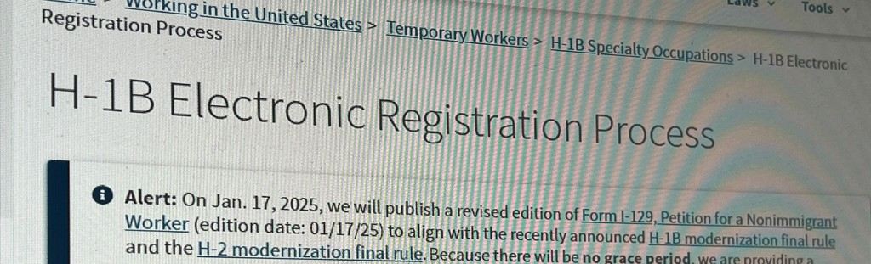

**©2025AmericanImmigrationLawyersAssociation**

**FlyerlastupdatedonSeptember26th,2025.**

AILAisthenationalbarassociationofimmigrationlawyerscomprisedofover15,000memberslocatedineverystateoftheUnitedStatesandworldwide.

*This flyer is intended for general information purposes only and does not constitute legal advice. You should not act or rely on any information in this flyer without seeking the advice of a competent, licensed immigration attorney.*