Presidential Proclamation Requires $100,000 Fee for New H-1B Workers
On September 19, 2025, the President issued a Proclamation that temporarily halts decisions on new H-1B petitions and bans entry of certain H-1B workers, unless a $100,000 fee is paid. The Proclamation took effect September 21, 2025, at 12:01 a.m. ET for twelve months (with the possibility of an extension).
While the language of the Proclamation initially appeared to apply to all H-1B workers who are outside of the United States on or after the effective date, the government has since provided guidance clarifying that it only applies to certain new H-1B petitions filed on or after September 21, 2025.

When Is Payment Required?
Who Is Affected?
H-1B petitions filed on or after 12:01 a.m. ET on September 21, 2025, to which one of the following conditions apply:
- The worker was outside the U.S. when the petition was filed
and does not have a valid H-1B visa stamp in their passport;
- The H-1B petition filed on behalf of the worker requests consular notification, port of entry notification, or pre-flight inspection; or
- The H-1B petition filed on behalf of the worker requested
a change of status, amendment, or extension, but USCIS determines the individual is ineligible for a change of status or an amendment or extension of stay.
- The $100,000 fee must be paid online before filing the H-1B
petition.
- At the time of filing, the petitioner must include proof that the payment has already been made, unless an exception applies.

Who is Not Affected?
- Individuals with an H-1B petition filed on their behalf before
12:01 a.m. ET on September 21, 2025.
- Individuals with a currently valid H-1B visa stamp.
- Canadians returning to the U.S. with an approved H-1B
petition filed before 12:01 a.m. ET on September 21, 2025.
- Individuals on whose behalf an H-1B petition was filed after 12:01 a.m. ET on September 21, 2025, requesting a change of status, amendment, or extension, and USCIS grants the change, amendment, or extension.
- Individuals who are granted an exception by DHS (see next column).

What Does the Proclamation Require?
- A $100,000 fee is required for all affected H-1B petitions.

Are There Any Exceptions?
An exception may be granted only in “extraordinarily rare” circumstances where DHS determines that:
- The beneficiary’s presence in H-1B status is in the national interest,
- No American worker is available to fill the role,
- The beneficiary does not pose a threat to U.S. security or
welfare, and
- Requiring payment would “significantly undermine U.S.

interests.”
Exceptions may be granted for:
- Specific individuals,
- All individuals working for specific companies, or
- All individuals in a specific industry.

What Should H-1B Workers and Employers Do?
Contact your immigration attorney to discuss whether this proclamation impacts your case, and do not make any
international travel plans or file any new H-1B petitions without first discussing with an immigration attorney. If you do not have one, you can find a licensed attorney at www.ailalawyer.com.


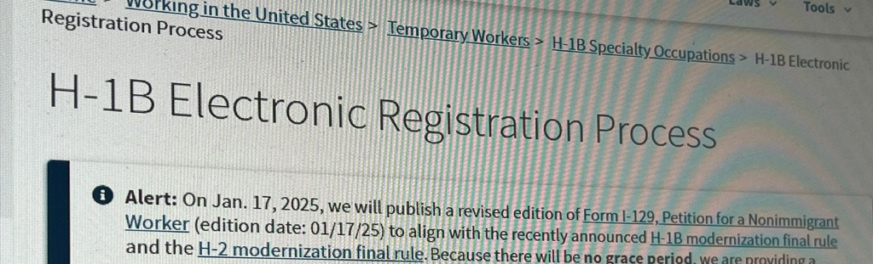
©2025 American Immigration Lawyers Association
Flyer last updated on November 10th, 2025.
AILA is the national bar association of immigration lawyers comprised of over 15,000 members located in every state of the United States and worldwide.
This flyer is intended for general information purposes only and does not constitute legal advice. You should not act or rely on any information in this flyer without seeking the advice of a competent, licensed immigration attorney.

