Government Shutdown

When Congress doesn’t pass a budget for the government on time, part of the government might stop operating. This is called a “government shutdown.” During a shutdown, only certain government employees can keep working. As of Oct 1, 2025, the federal government has officially shut down.

This handout describes what might happen to immigration-related agencies during the government shutdown.

# Department of Homeland Security (DHS)

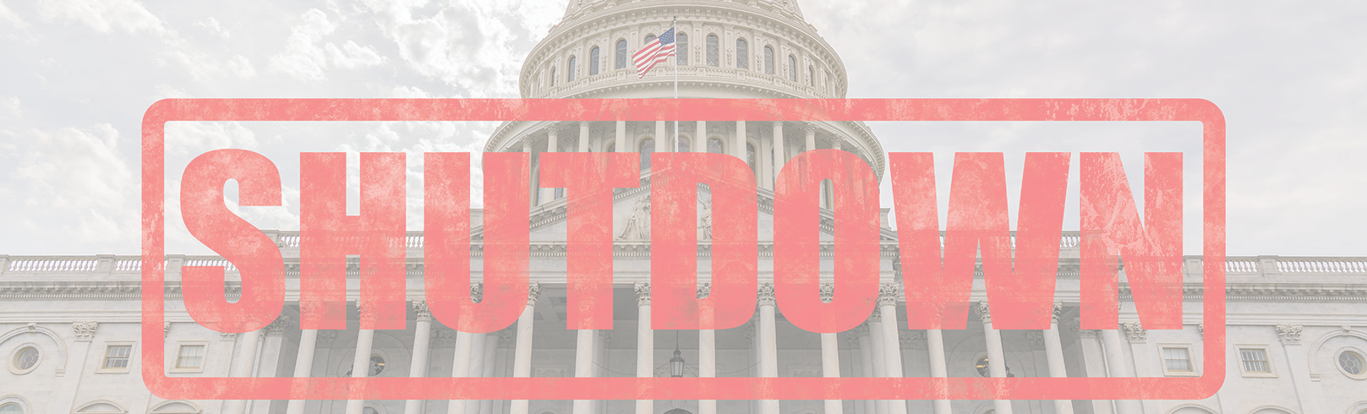

Most of DHS’s work is considered essential, so DHS will remain open.

# U.S. Citizenship and Immigration Services (USCIS)

USCIS will remain open as it does not rely on Congress for its funding. The few programs that are funded by Congress may be impacted by a government shutdown. Notably, E-Verify will not be available for employers to verify employment eligibility.

# Department of State (DOS)

Visa and passport operations will remain open; however, depending on how long the shutdown lasts, work might become limited to diplomatic visas and life-or-death emergencies.

# Customs and Border Protection (CBP)

Ports of entry will remain open; however, applications that

are filed at the border may be impacted.

# Immigration and Customs Enforcement (ICE)

ICE enforcement and removal operations will continue. The ICE Student and Exchange Visitor Program (SEVP) offices will remain open.

# Executive Office for Immigration Review (EOIR)

Immigration court cases for both detained individuals (the “detained docket”) and non-detained individuals (“non-detained docket”) will continue during the government shutdown.

# Department of Labor (DOL)

DOL’s Office of Foreign Labor Certification (OFLC) will

stop all operations during a government shutdown. Access to the Foreign Labor Gateway Application (FLAG) is turned off and new cases cannot be filed and information cannot be accessed.

# CIS Ombudsman

The DHS Office of the CIS Ombudsman will stop all

operations during a government shutdown.

# Congressional Constituent Services

Some congressional offices may be closed during a government shutdown. Please contact the individual office for more information.

**This flyer is intended for general information purposes only and does not constitute legal advice. You should not act or rely on any information in this flyer without seeking the advice of a competent, licensed immigration attorney.**

**We are closely monitoring the situation and encourage you to contact our office at [NAME] at [NUMBER] if you have any questions.**